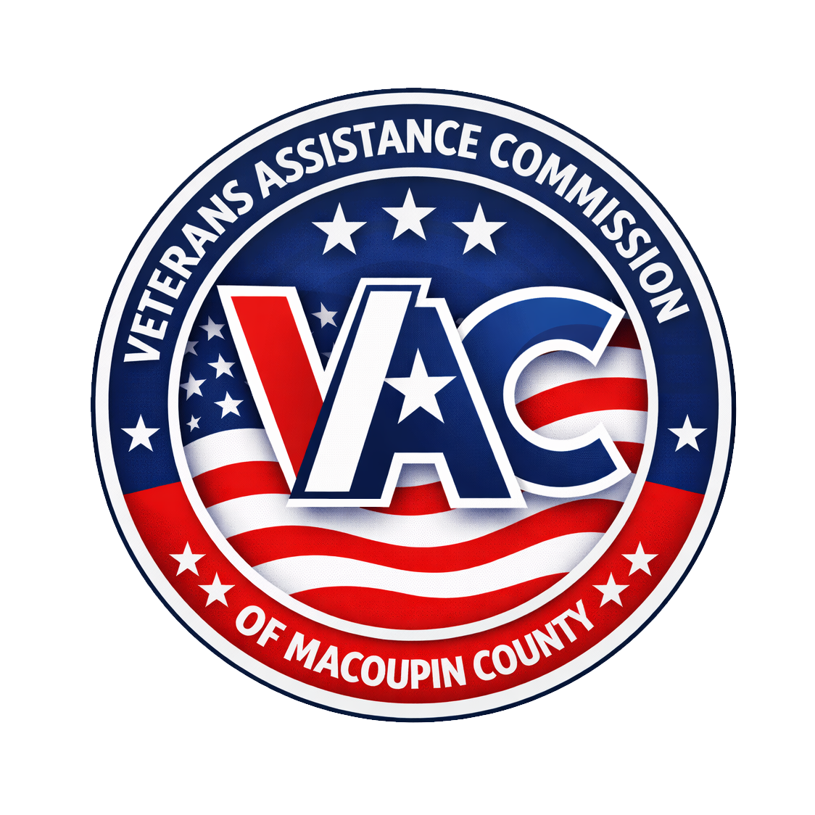
VETERANS ASSISTANCE COMMISSION
of Macoupin County, Illinois
Freedom of Information Act (FOIA) Request Form
Under the Illinois Freedom of Information Act (5 ILCS 140), you may request to inspect or copy the public records of the Commission. Complete this form and submit it by mail, in person, email, or fax (see below). We will respond within five (5) business days of receipt; a limited extension may apply under the Act.
Requester Information
Name:
Mailing Address:
City / State / ZIP:
Phone: Email:
Date of Request:
Records Requested
Describe the records you are requesting as specifically as possible (dates, subject, type of document):

How would you like to receive the records?
[ ] Inspect the records in person [ ] Paper copies [ ] Electronic copies (by email)
Note: The first 50 pages of standard black-and-white letter- or legal-size copies are provided at no charge; fees for additional copies follow the Illinois FOIA fee schedule.
Commercial Purpose
Is this request for a commercial purpose? [ ] Yes [ ] No
A request for a commercial purpose may be answered within twenty-one (21) business days under 5 ILCS 140/3.1.
Signature: Date:
How to Submit This Request
By mail: Veterans Assistance Commission of Macoupin County, P.O. Box 12, Carlinville, IL 62626
In person: 570 North Broad Street, Carlinville, IL 62626
By email: macvac@macvac.org
By fax: (217) 716-2311
FOIA Officer: Jordan Cervi
For Office Use Only
Date received: __________________ Tracking No.: __________________
FOIA Officer: Jordan Cervi Response due (5 business days): __________________
Disposition: [ ] Granted [ ] Partially granted [ ] Denied [ ] Extension (5 ILCS 140/3(e))
Notes: ____________________________________________________________________

